1c–My-Fires-Data-Exploration
Elizabeth Buhr
2025-10-20

Extent of Treatments in Individual Fires
## Warning: Removed 2 rows containing missing values or values outside the scale range
## (`geom_bar()`).
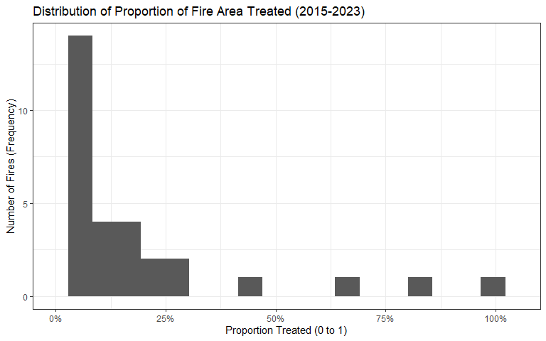

Size of Treatments
Summary statistics in hectares:
## # A tibble: 4 × 6
## MGT_TYPE n min max mean sd
## <chr> <int> <dbl> <dbl> <dbl> <dbl>
## 1 CANOPY 1631 7.48e-10 3819. 23.1 147.
## 2 RX FIRE 771 3.37e- 8 2026. 18.2 96.4
## 3 SURFACE 925 1.46e- 8 90.4 4.95 10.1
## 4 Wildfire 25 3.50e- 1 2798. 378. 579.

